|  |
| --- |
|  |
| 新概念 3 册 |
| Lesson28 |

Lesson 28 Five pounds too dear

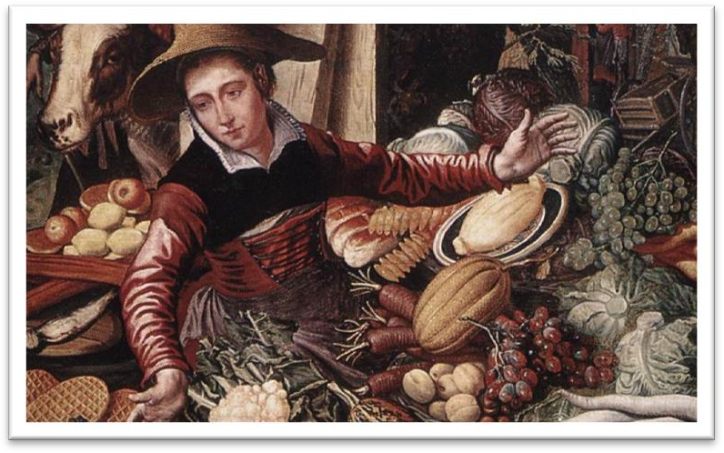

**wares [weəz]**

**n. 货物，商品**

ware n. 某种产品（不可数）

software hardware

silverware ironware

chinaware earthenware goods merchandise

anchor ['æŋkə(r)]

**v. 抛锚**

They anchored the ship in the harbor. The ship anchored in the harbor.

cast / drop anchor weigh anchor / set sail **tempt [tempt]**

v. 吸引，引诱

tempt sb. to do sth. tempt sb. into doing sth.

The serpent tempted Eve to pick the forbidden fruit.

The serpent tempted Eve into picking the forbidden fruit. lure / seduce / entice sb. into doing sth.

I guess I set up the video camera to try and entice Joey. But sadly I could not be enticed.

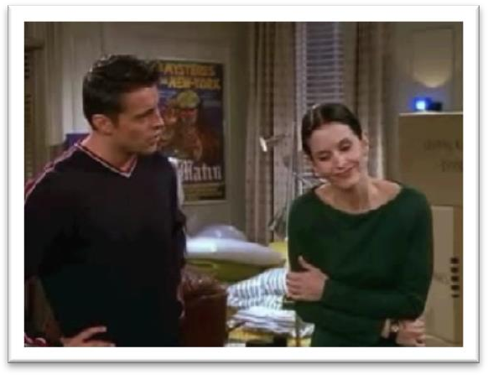

bargain ['bɑ:ɡən]

**v. 讨价还价**

bargain with sb. over / about sth.

He bargained with the vendor over / about the price of the eggplants. haggle with sb. over / about sth.

Oh, this one’s nice! I like this one! Sir? Uh, kind sir? Can I see this one?

Wait a minute, no, this is, this is the reason you brought me. Okay? I know how to haggle. So let me handle this from here on out.

bargain / buy

Oh my! Here‘s a real buy. It's a bargain. This house just came on the market.

disembark [dɪsɪm'bɑ:k]

**v. 下船，下飞机**

**disembark from …**

The passengers disembarked from the ferry / plane.

embark on …

We embarked on the ship for Shanghai.

board

The couple boarded the train for New York. Flight No. 714 is now boarding at Gate 8. **assail [ə'seɪl]**

v. 纠缠

be assailed by / with …

He was assailed by / with a street vendor. He was assailed by / with worries.

pester harry harass

From the moment he arrived there, he kept on pestering his doctor to tell him when he would be able to go home.

sexual harassment

inscribe [ɪn'skraɪb]

**v. 刻字；题写**

“in” + “scribe”(= to write)

He inscribed his name in the stone.

He inscribed his name in the book. describe

prescribe proscribe subscribe transcribe

**outrageous [aut'reɪdʒəs] adj. 出人意料的，过分的**The price is outrageous.

The price is preposterous. The price is absurd.

That’s highway robbery / daylight robbery. The car costs a fortune.

The car costs me an arm and a leg.

Linda didn't like it.

Bill lost it.

It was very expensive.

It was very small.

M: Did you see the diamond ring Bill gave to Linda? W: I sure did. It must have cost him an arm and a leg. Q: What does the woman imply about the ring?

Answer: (C) It was very expensive. dear: expensive; costly; pricey; steep Italian ex-mayor murdered

Small boats loaded with wares sped to the great liner *as she was entering the harbour*.

Small boats (which were) loaded with wares ……

be loaded with …

They quickly loaded a small rubber dinghy with food, matches, and cans of beer and rowed for a few miles across the Caribbean until they arrived at a tiny coral island.

be covered with … be filled with …

… it is filled with what looks like a thick, greyish substance.

All at once, I noticed that my wife seemed to be filled with alarm. be packed / crammed with …

It has been estimated that if the bridge were packed with cars, it would still only be carrying a third of its total capacity.

The streets were packed / crammed with Christmas shoppers.

be stuffed with …

a pillow stuffed with feathers

duck stuffed with ‘eight treasures’ stuffed birds

I’m stuffed. = I’m full.

He was fined for speeding.

We sped down the ski slopes.

The tragic sinking of this great liner will always be remembered, for she went down on her first voyage with heavy loss of life.

enter the harbor depart from the harbor

pull / draw in the station pull / draw out of the station

Before she had anchored, the men *from the boats* had climbed on board and the decks were soon covered with *colourful rugs from Persia*, *silks from India*, *copper coffee pots*, and *beautiful handmade silverware*.

Before she had anchored, …

Before she had dropped / cast anchor, … on board = aboard adv. & prep.

one of the most colorful figures

|  |  |  |
| --- | --- | --- |
| rug | carpet | mat |
| doormat |  | bathmat |
| blanket |  |  |
| **copper** | **bronze** | **brass** |
| the Bronze Age |  |  |
| a brass band |  |  |

potbelly coffee pot teapot

flowerpot kettle

the pot calling the kettle black pan frying pan

out of the frying pan into the fire

It was difficult to avoid being tempted.

No one can avoid being influenced by advertisements. It was difficult to resist temptation.

Many of the tourists on board had begun bargaining with the tradesmen, but I decided not to buy anything until I had disembarked.

I shaved before I went to the party.

…, but I decided to disembark before I bought anything. before buying anything.

I had no sooner got off the ship than I was assailed by a man who wanted to sell me a diamond ring.

no sooner … than …

**hardly / barely / scarcely … when / before …**

No sooner *had* I got off the ship than I was assailed … I *had* hardly got off the ship when I was assailed … Hardly *had* I got off the ship when I was assailed … get off the bus / ship / plane

I had no sooner disembarked from the ship than …

get on the bus / ship / plane get into the car / taxi

get out of the car / taxi

… than I was harried / harassed / pestered by a man who …

I had no intention of buying one, but I could not conceal the fact that I was impressed by the size of the diamonds.

have no intention of doing sth. not intend to do sth.

She intended to dress up as a ghost and as she had made her costume the night before, she was impatient to try it on.

I didn’t intend to buy one, …

…, but the man must have noticed that I was …

…, but I could not deny that I was …

…, but I had to admit / acknowledge that I was …

造句：我当时并没有打算在这家公司工作，但我不能掩饰这样一个事实：他们提供的丰厚的薪水 (handsome salary) 给我留下了深刻的印象。

I had no intention of working for the company, but I could not conceal the fact that I was impressed by the handsome salary they offered.

go to great lengths to do

They have gone to great lengths to make us feel welcome. do / try one’s best to do

Though the doctor did his best, the patient's recovery was slow. do / try one’s utmost to do

You play to win, and the game has little meaning unless you do your utmost to win. do everything / all one can to do

give one’s all to do spare no effort to do

China will spare no effort to realize peaceful reunification. go all out to do

They should wait for John to bring the dessert.

He thinks John must have spent a lot of money for the dinner.

The dessert also looks impressive.

He helped John make the sandwiches.

W: Look at the delicious sandwiches. John’s really gone all out this time. M: Just wait until you see the dessert.

Q: What does the man imply?

Answer: (C) The dessert also looks impressive.

…… and it gave me the impression that it was about to leap out at me. have / get the impression that …

be under the impression that ...

Though the crew were at first under the impression that the lost ship had been found, the contents of the chest proved them wrong.

He hit me on the nose.

He hit me in the face.

If you are lucky enough to get a sleeper, you spend half the night staring at the small blue light in the ceiling, …

I took over half an hour to get rid of him.

The journalist immediately set out to obtain these important facts, but he took a long time to send them.

I spent over half an hour (in) getting rid of him.

get rid of sb. dispose of sb.

There is no quicker method of disposing of patients than by giving them what they are asking for, …

expel

He was expelled from school for bad behavior.

the first, the second, the next, the last, the best, the only … 后常跟不定式作定语

The next man *to approach me* was selling expensive pens and watches.

When he landed near Dover, the first person *to greet him* was a local policeman. The only other ship *to match her* was the Thermopylae.

The first of the two ships *to reach Java* after the race had begun was the Thermopylae, but on the Indian Ocean, the Cutty Sark took the lead.

The last creature *to compete with man* was the mosquito. My birthday is fast approaching.

My birthday is coming soon. My birthday is near at hand.

My birthday is just around the corner. closely = carefully

… advertisers have made a close study of human nature… at the base of …

on the basis of …

Decisions were often made on the basis of false information.

gold gold ring / medal

**golden golden sunshine / hair**

Speech is silver, but silence is golden. His handwriting is neat.

He has a teacher’s handwriting. His handwriting is illegible.

He has a doctor’s handwriting. inscribe engrave

Historians have long been puzzled by dots, lines and symbols which have been engraved on walls, bones, and the ivory tusks of mammoths.

The man said that the pen was worth £50, but *as a special favour*, he would let me have it for

£30.

I shook my head and held up five fingers indicating that I was willing to pay £5. I shook my head …

I disagreed …

I said no to him …

hold up = extend 伸出

indicate = signify（间接地）表示

Her tone indicated that she didn’t believe a word of my explanation. She signified her agreement by nodding her head.

… held up five fingers signifying that I was …

Gesticulating wildly, the man acted *as if he found my offer outrageous*, but he eventually reduced the price to £10.

outrageous absurd preposterous

**eventually at last finally**

**in the end**

*Shrugging my shoulders*, I began to walk away when, *a moment later*, he ran after me and thrust the pen into my hands.

shrug one’s shoulders with a shrug

I will be on vacation till the end of the month when I return to shanghai.

run after = chase

Just as it was leaving, Mr. Taylor rushed out and ran after it throwing ashtrays and vases, …

readily = willingly

There are times when we would willingly give everything we possess to save our lives, …

No matter how hard I tried, it was impossible *to fill this beautiful pen with ink* and *to this day* it has never written a single word!

However hard I tried, …

Judges, however wise or eminent, are human and can make mistakes.

Imagine their dismay when they found a beautifully-cooked wallet and notes turned to ash.

to this day = so far

I spent the whole day in my room, but I did not write a single card!

He earned enormous sums of money and was paid as much as ￡100 for a single appearance. They had a single aim, a solitary goal—the top!

造句：无论我多么好地喂养 (feed) 这只鸡，它就是不肯产卵 (breed)，直到今天它连一个蛋也没下过。

No matter how well I fed her, it was impossible to persuade the beautiful hen to breed and to this day she has never laid a single egg!

